**Micro-project Report**

***Car Showroom management***

**1.0 Brief introduction**

As we all know, the car showroom has the collection of cars. Cars of various models are available at car showroom. This micro project contains 5 sections first information about cars, second section contains of availability of cars, third section is of registration, fourth section includes the payment and last is the exit option. The micro project contains of two classes info and register. Info is a base class and register class is publically derived from info class. This project can be used to register the purchased cars.

The micro project is based on real world applications of object oriented programming. The program states that the object oriented programming is much better than procedure oriented programming. The code includes various brands of cars such as BMW, Porsche, Ferrari and Mercedes. Various of these cars are also included in the project. User can get any information related to the showroom in the program. The project is efficient.

**2.0 Aim of the project**

This micro-project aims were

1. To Provide buyer with the required specifications of respective models of car.
2. To Study the use of Inheritance in real life Applications.
3. To Study the use of classes and objects in real life applications.
4. To Register the information of user according to car purchased.
5. To Study the actual car showroom management.

We have achieved all the aims which were decided at the start of the project. We have completed the project with achieving all the aims at the completion.

**3.0 Course Outcomes Integrated**

1. Implementing given type of inheritance in C++ program.
2. Explain given types of inheritance based on characteristics.
3. Create the object and call the member functions of class.

**4.0 Actual procedure followed**

Actual procedure followed during the project is mentioned in the table below with the planned start date and completed finish date.

|  |  |  |  |  |
| --- | --- | --- | --- | --- |
| Sr.no | Details of activity | Planned  Start date | Completed  Finish date | Name of responsible Team members |
| 1. | Collected the information of car showroom management | 01/07/2018 | 08/07/2018 | 1.Patil Vinayak  2.Surve Prathamesh |
| 2. | Decided the overall structure of the project | 09/07/2018 | 20/07/2018 | 1.Patil Pratik  2.Chavan Shubham |
| 3. | Collected information about BMW | 21/07/2018 | 30/07/2018 | Patil Vinayak |
| 4. | Collected information about  Porsche | 21/07/2018 | 30/07/2018 | Surve Prathamesh |
| 5. | Collected information about  Ferrari | 21/07/2018 | 30/07/2018 | Chavan Shubham |
| 6. | Collected information about  Mercedes | 21/07/2018 | 30/07/2018 | Patil Pratik |
| 7. | Created coding structure | 01/08/2018 | 07/08/2018 | 1.Patil Pratik  2.Surve Prathamesh |
| 8. | Typed the coding and creating the actual project and observing the output | 08/08/2018 | 01/09/2018 | 1.Patil Pratik  2.Surve Prathamesh  3.Chavan Shubham  4.Patil Vinayak |
| 9. | Made report on created project | 02/09/2018 | 15/08/2018 | 1.Surve Prathamesh  2.Patil Vinayak  3.Patil Pratik  4.Chavan Shubham |

**5.0 Actual Resources Required**

The resources used during the completion of project are mentioned in the below table:

|  |  |  |  |  |
| --- | --- | --- | --- | --- |
| Sr.no | Name of resources material | Specifications | Quantity | Remarks |
| 1. | Internet | Network of Networks | 1 |  |
| 2. | Turbo C7 | TURBO C++ compatible with Windows 7,8 and vista | 1 |  |
| 3. | Microsoft Word | 2007 version | 1 |  |
| 4. | Mr. S.P. Emekar | Faculty, CO dept, GP Karad | - |  |
| 5. | Miss. P.A.Patil | Faculty, CO dept, GP Karad | - |  |

**6.0 Outputs of the Micro-project** 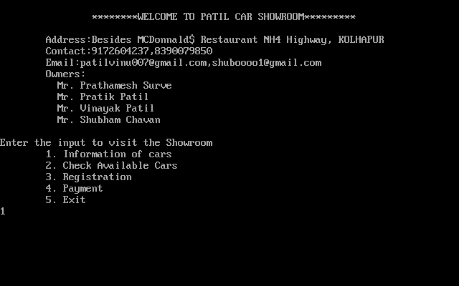

Fig 1. The above figure is the main screen of the microproject

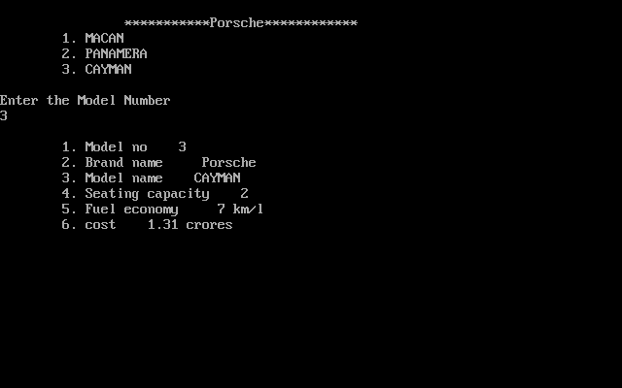

Fig 2. The above screenshot is the information provided to user of cars which he/she wants.

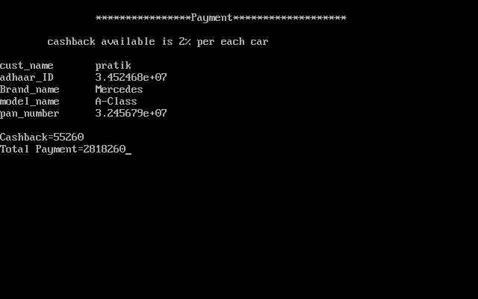

Fig 3. The above screenshot is the payment of the car purchased by the user

**7.0 Skill Developed/ learning out of this Micro-Project**

The project was really very exciting as it was about everyone’s favourite cars. Various skills got developed in us by doing this project. This skills are

1. Performing the role of manager of the car showroom.
2. Working as the owner of car showroom.
3. Creating the C++ programs for various applications efficiently.
4. Debugging the errors.
5. Using the concept of Object Oriented Programming.
6. Doing the business.
7. Efficient communication skills.

This were skills developed by us during the project.

Learning’s were about the communication skills. What kind of communication is needed for business. We understood that, we need to improve our communication skills. We are lacking in it.

**Submitted By:**

1.Patil Pratik Kumar 856

**Subject teacher**

**Miss. Patil Y.P.**